Create a New Breed of SPIDER!
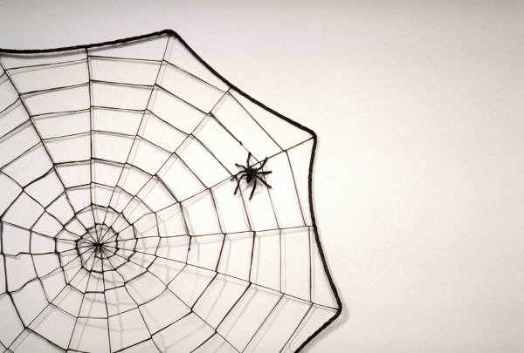

Your mission is to invent a new breed of spider. Use your imagination!

_____ Make a poster about your new spider with an illustration and write a fact sheet about your new breed of spider.

Facts you must have, but are not limited to:

- Name your breed of spider
- Describe your spider’s physical features (size, color, etc.)
- Your spider’s habitat (where it lives)
- Unique habits or traits of your spider

BE CREATIVE AND HAVE FUN!!!!!

